Login to MBDL site | https://www.leaguelineup.com/schedulesearch.asp?url=mbdl&sr=1
Select Schedues | 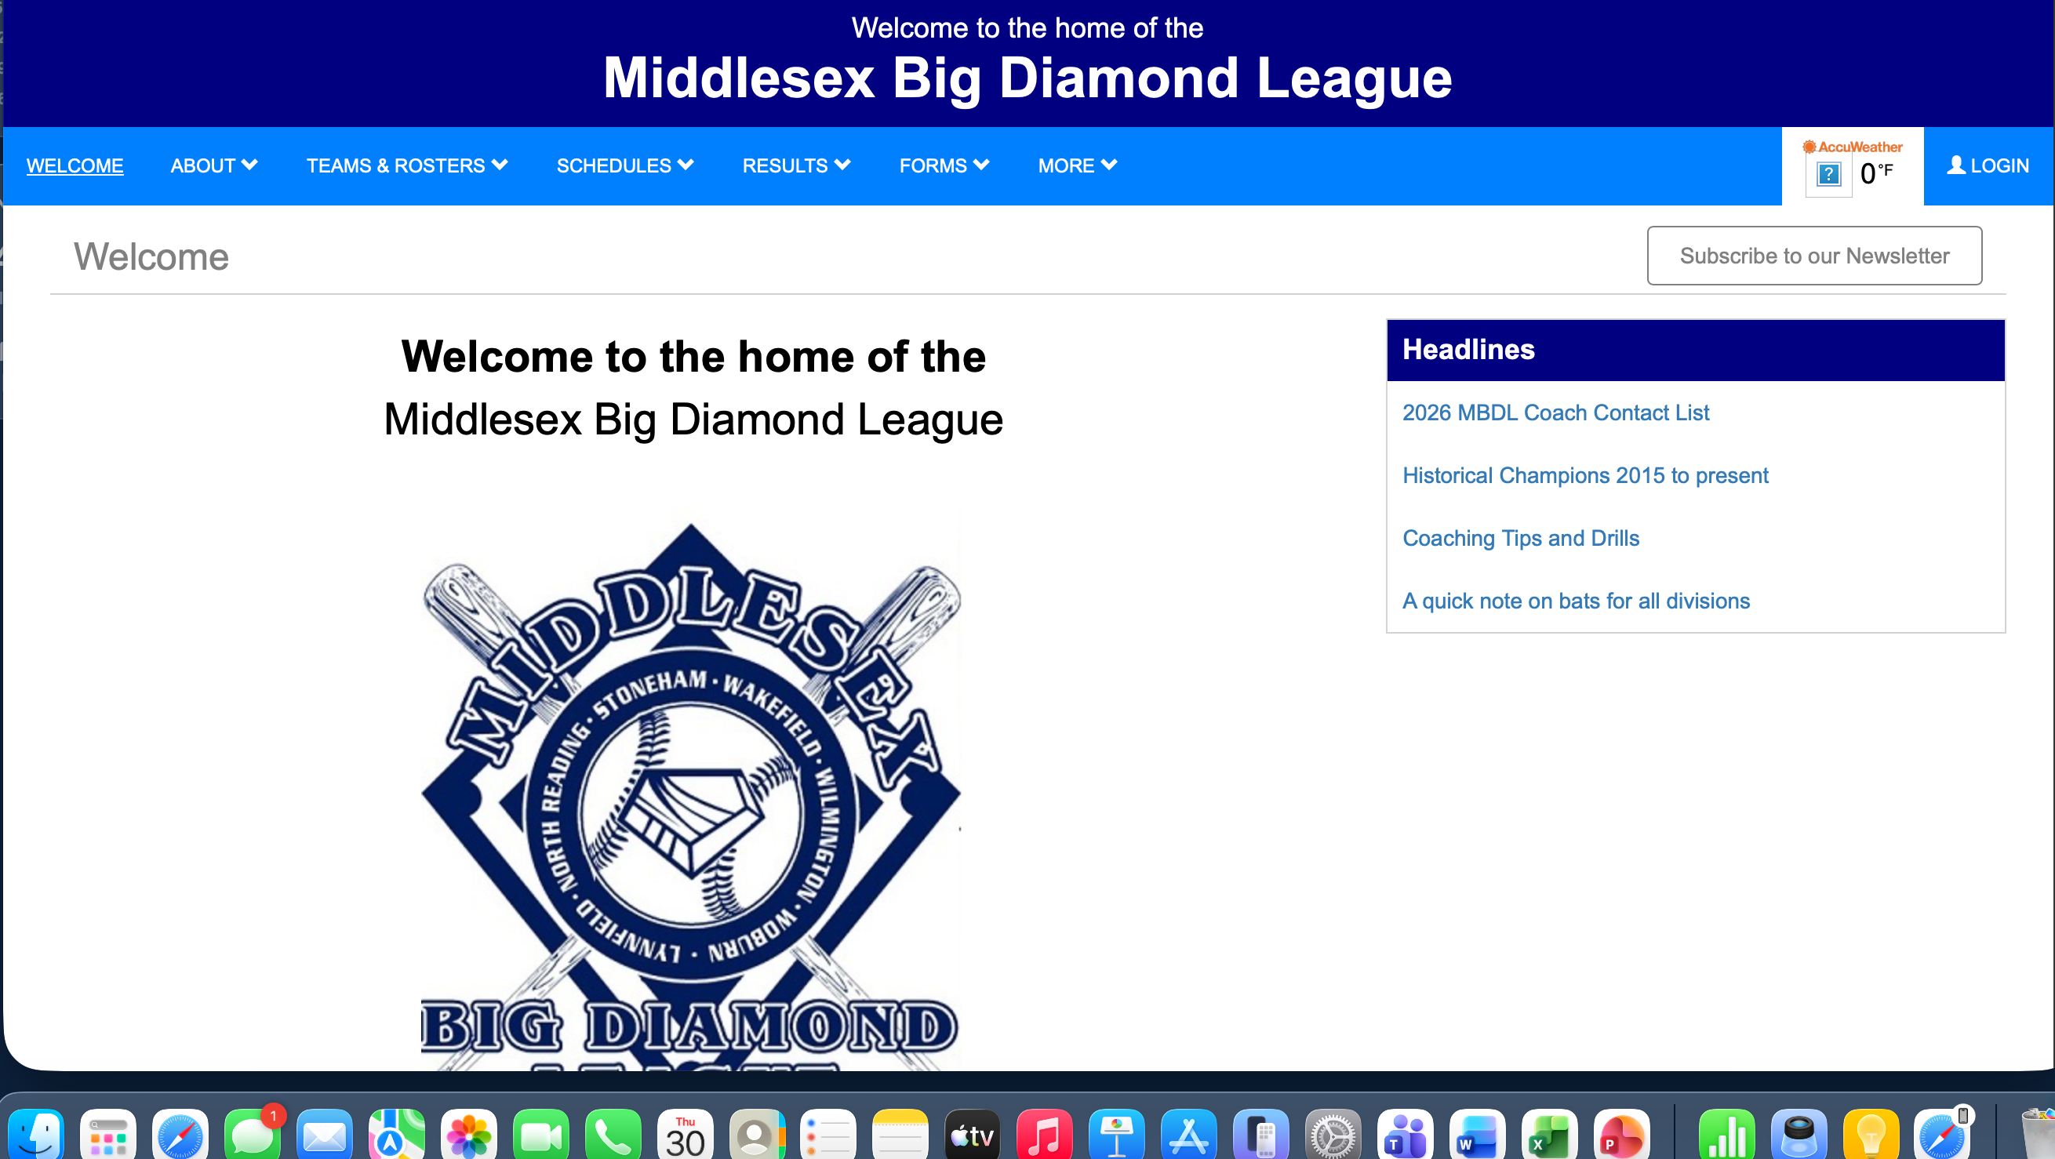
Select Report Scores | 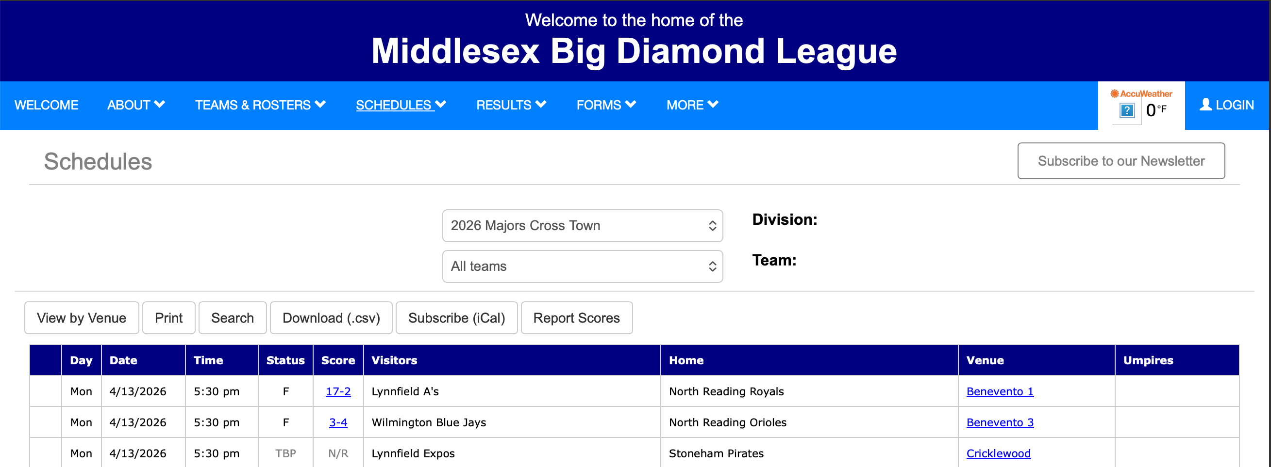
Enter date range for game(s) in Crosstown Division  And Password  (sent in a prior email) | 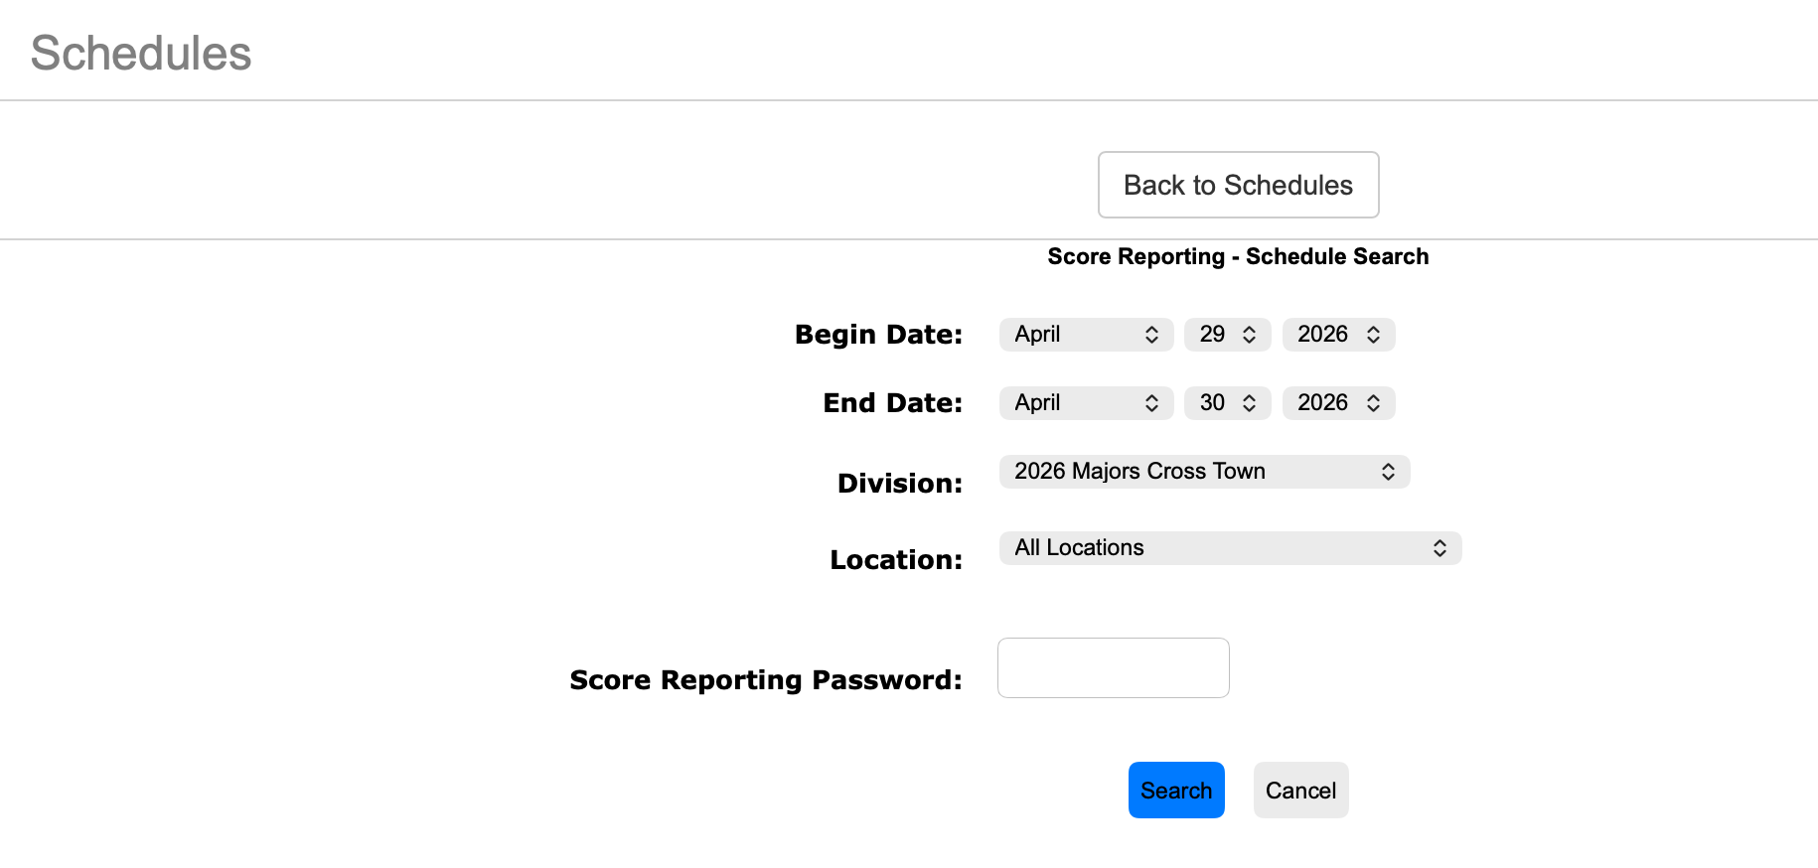
Select Report Scores/Pitches | 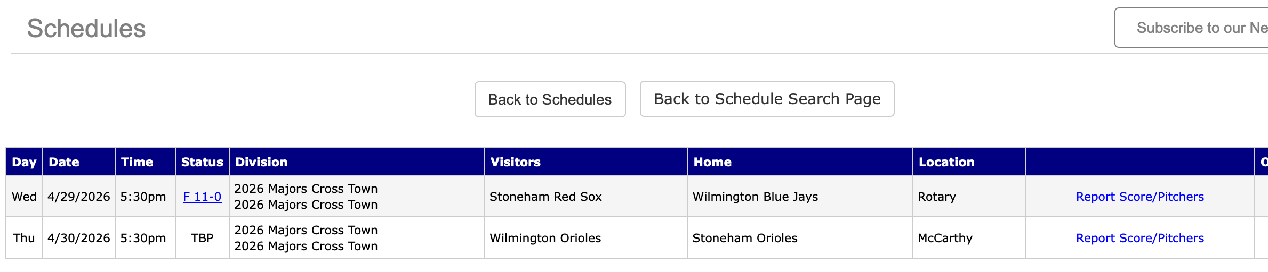
Update Game Status, Score, and Pitch Count | 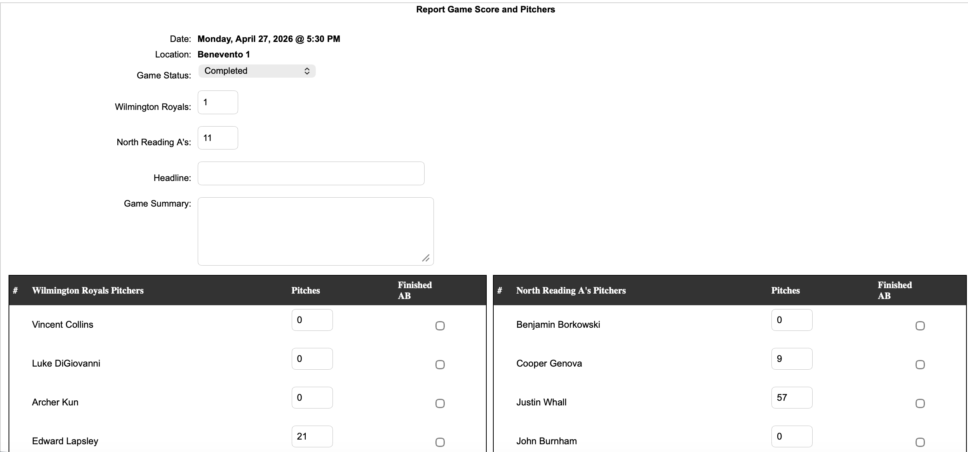
Submit

